**Passion for Dance turns into an Institute in Kolkata**

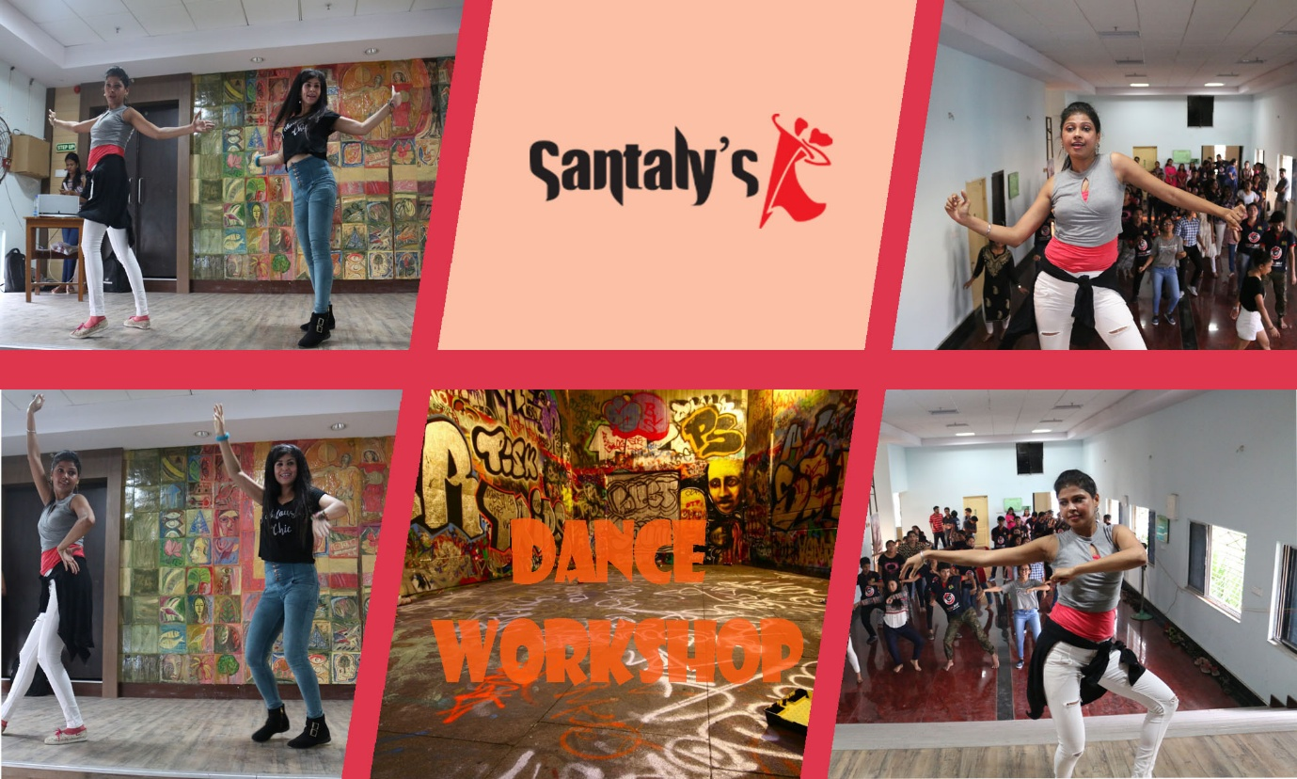

It is truly said that passion and determination carves the path for success. In the past few years SANTALY’s Dance and Music Institute have gained predominance as one of the biggest dance institute in Kolkata. Santaly Sarkar and Sonia Sarkar, the directors of the Institute were dedicated to dance since childhood but little did they knew that their passion will make them one of the best dance performers in Kolkata.

Santaly Sarkar Is well trained Kathak dancer under Pandit Shyamal Maharaj and Pandit Birju Maharaj While she is also trained in western contemporary under the likes of Andrea and Silvia.

Sonia Sarkar, the other director and sibling of Santaly has completed her training of classical jazz under the supervision of Shiamak Davar also, she is trained in Bharatanatyam.

Subeer Sarkar, a well-known Indian magician is the father of both the directors. The siblings have learnt the art of magic from their father. Then along with the time they have learnt to implement the magic tricks with dance and from thereon they have never looked back.

SANTALY’s Dance and Music Institute have professional dancers who provide training to the students in different forms of dance. The institute not only provides training in dance but also in different in music and gymnastics. In the Institute, the students are provided the skills in the positive environment that nurtures their creativity in the form of dance and music.

The Institute also organizes events, seminars and workshops where students are encouraged to perform and thus portray their talent along with they are provided with different opportunities that will help them in climbing the ladder of success.

The training institute also focusses on the overall personality development of the students also they are taught about the need of punctuality, integrity and discipline that will help them in achieving the goals of their life.

**Diversified courses offered by the Institute**

SANTALY’s Dance and Music Institute is the temple of dance and music where students are provided training in diversified courses. The courses are designed as per the interest of the students. The motto of the institute is “there is not age to learning” that personifies that anyone irrespective of their age have the right to learn. The trainers of this institute also believe on this motto and thus different types of courses are provided to everyone. The courses are provided in Dance, Music, Zumba and Gymnastic.

The students are provided training in different forms of dance that include Indian Classical Dance, Indian Folk Dance, Western Classical Dance and Ballroom. The dance courses are designed separately for kids, teens and the adults.

**Indian Classical Dance**

Indian Classical Dance has its roots originated from religious Hindu musical theatre styles. According to Sangeet Natak Akademi there are around eight or more recognized classical dances that includes Bharatanatyam, Kathak, Kuchipudi, Odissi, Kathakali, Sattriya, Manipuri and Mohiniyattam. Scholars such as Drid Williams add Chhau.

**Bharatanatyam**

Bharatanatyam is known as one of the significant part of Indian classical Dance. It is believed that this dance form has its origin in Tamil Nadu. Bharatanatyam is the classical forms of dance that was usually performed by women.

**Indian Folk Dance**

Folk Dance usually refers to different forms of folk and tribal dances in different regions across India. Folk Dance are usually performed during religious and festival occasions in the form of Bhangra, Garba, Kalbelia and Bihu by different groups in rural region of India.